Name _________________________________ Fingerprint Notes

Period ________ Date ___________________ Forensics

1. What are fingerprints?
   1. ____________________________________________________________________________________________________________________
   2. ____________________________________________________________________________________________________________________
2. Fingerprint Skin
   1. __________________________________________________________
      1. They make our fingers ___________________________________.

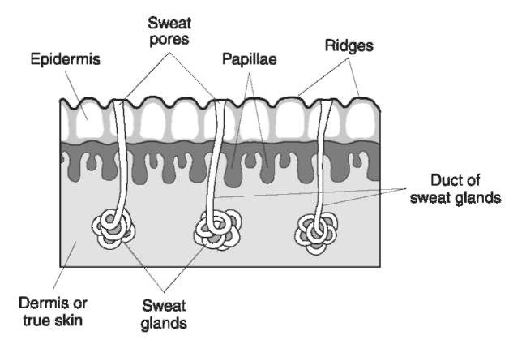

1. Fingerprint History
   1. ____________________________________________________________________________________________________________________
      1. 1792 – 1750 BC _________________________________________
      2. Ancient china __________________________________________
   2. In the Western Culture
      1. 1684 – ________________________________________________
      2. 1788 – ________________________________________________
         1. “________________________________________________________________________________________________”
      3. 1879 Alphonse Bertillion, _________________________________
      4. 1896 Sir Edmund Richard Henry ___________________________ ______________________________________________________

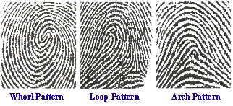

1. Formation of Fingerprints
   1. ____________________________________________________________________________________________________________________
   2. __________________________________________________________
      1. ____________________________________________________________________________________________________________
   3. ____________________________________________________________________________________________________________________
   4. ____________________________________________________________________________________________________________________
      1. ____________________________________________________________________________________________________________
      2. ____________________________________________________________________________________________________________
      3. ____________________________________________________________________________________________________________
      4. ______________________________________________________
   5. Similar prints are formed at the same time: __________________________________________________________
   6. Identical twins _____________________________________________.
   7. 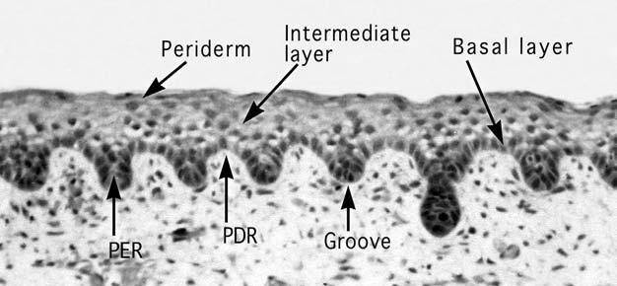

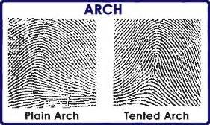

1. There are Basic Types of Fingerprints
   1. __________________________
   2. ___________________________
   3. 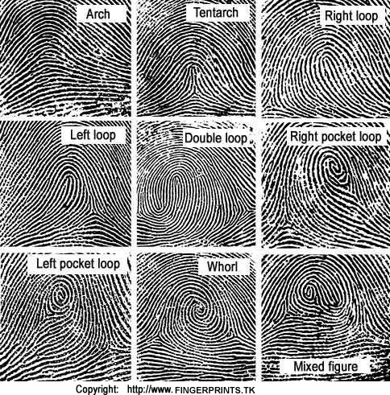_____________________________

_____________________

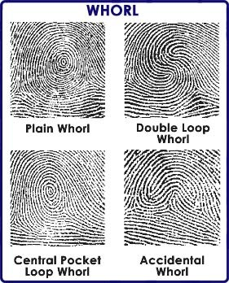

1. Fingerprint Minutiae______________________________________________

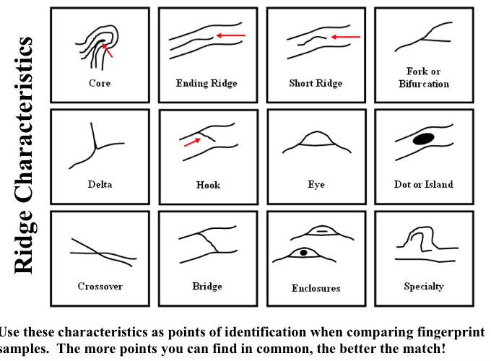

1. Fingerprint ridge counting is another way _____________________________
   1. ____________________________________________________________________________________________________________________

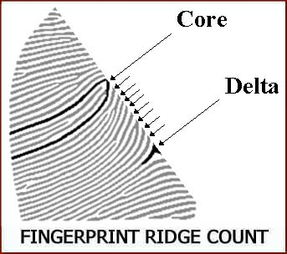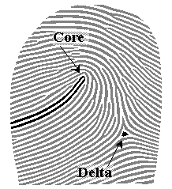

1. Types of fingerprint identification
   1. __________________________________________
      1. ____________________________________________________________________________________________________________
   2. ____________________________________________________________________________________________________________________
   3. __________________________________________
      * 1. _________________________________________________
        2. _________________________________________________
2. Fingerprint Facts
   1. Can fingerprints be altered?
      1. ______________________________________________________
      2. If fingerprints are altered_________________________________
   2. How reliable is fingerprinting?
      1. ______________________________________________________
      2. Out of 185 examiners studied, ____ people made a false positive.
   3. How are fingerprints Analyzed?
      1. Until 1999 _____________________________________________
      2. ____________________________________________________________________________________________________________
         1. _________________________________________________
         2. _________________________________________________
3. Latent Fingerprint collection
   1. Dusting with fine carbon powder that can “bring out” fingerprints.
   2. Tape is then used to lift and preserve the prints.
   3. Magnetic powders can also be used.
   4. To recover a print from a surface that is not hard and smooth requires the use of different chemicals.
   5. When fingerprint residue combines with chemicals the print becomes visible.

|  |  |  |  |  |  |
| --- | --- | --- | --- | --- | --- |
| Chemical | Uses | Application | Safety | Chemical Reaction | Latent Print |
|  | Paper | Object dipped or sprayed | Do not inhale or get on your skin | Reacts with amino acids found in sweat |  |
|  | Household items, plastic, metal, glass and skin | Heat sample in a vapor tent | Do not inhale or get on skin, irritant to mucus membranes | Reacts with amino acids |  |
|  | Wood, Styrofoam | Object diffed or sprayed | Wear gloves, avoid contact to skin | Chloride from salt in perspiration on the print combines with silver nitrate to form silver chloride |  |
|  | Paper, cardboard, unpainted surfaces | In a vapor tent, heat solid iodine crystals | Toxic to inhale or ingest | Iodine combines with carbohydrates in print |  |